SM-1 Service module
Technical specifications and assembly instructions
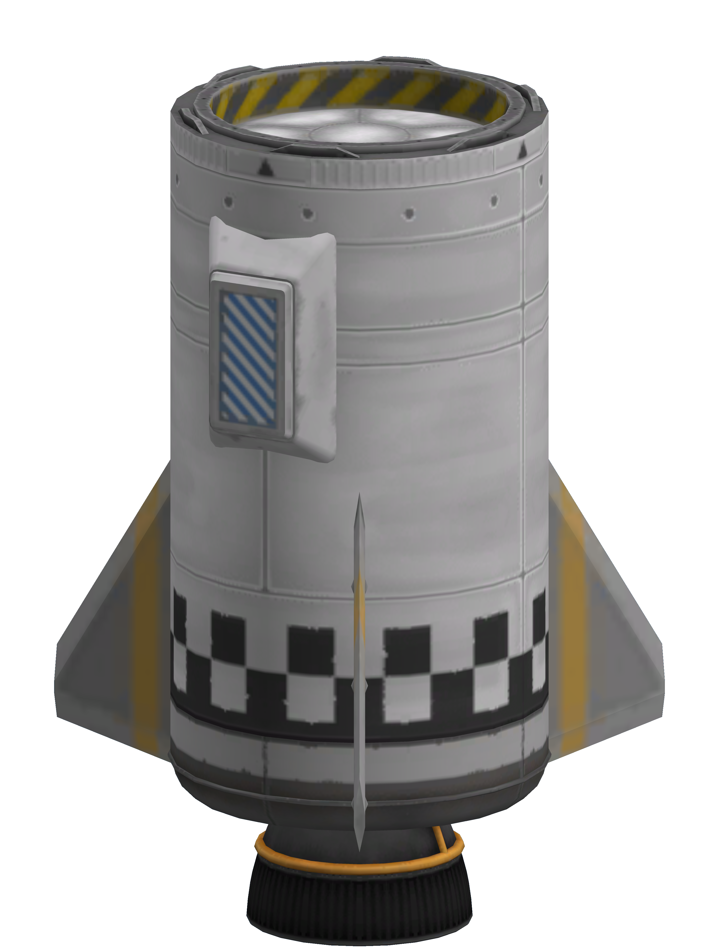

Description
The SM-1 is a low tech, computerless and recoverable service module. The SM-1 is designed to operate with naked capsules on top and to provide both launch services and orbital maneuvering capabilities.
Recovery is done with parachutes. The stage is able to re-enter Kerbin’s atmosphere on its own, requiring only a new set of fins during refurbishment.

Basic construction
The SM-1 is constructed in an integral manner, starting from the T400 tank. Pieces are simply attached to it. No subassemblies are used, but certain parts require precision positioning and reusing already built savefiles is encouraged.
Only a single variant is used.

Guidance system
The stage is usually guided by the gimballing rocket exhaust and whatever method is used in the capsule being carried by it. Since the stage is designed for naked capsule mounting and the only type of the proper size is a Mk-1 pod, the capsule usually provides its gyros to assist in guidance.
The three relatively small fins provide upper stage stability without excessively shifting the centre of pressure when attached to a properly sized lower stage.

Re-entry system
Re-entry is achieved passively. The SM-1 has a centre of mass close to its engine, which allows it to passively obtain the proper re-entry orientation. The fins used for launch stabilisation are destroyed during re-entry and need to be replaced during post-flight maintenance. They are cheap and don’t add much to the maintenance time if KCT is used.

Recovery system
SM-1 recovery is achieved via parachutes. The parachute system is overengineered both as a redundancy measure and because of the impossibility to use a single central parachute at its technology level (lacking cubic struts). The service module can land with full propellant tanks. This excessive braking capacity can be used to recover a damaged capsule by landing with the service module attached.

Assembly instructions
Assemble rocket starting from one of the core parts. Store a savefile of the assembled stage for further reference after assembly.

Parts list
1x FL-T400 Fuel Tank
1x LV-909 "Terrier" Liquid Fuel Engine
1x TD-12 Decoupler
3x Basic Fin
2x Mk2-R Radial-Mount Parachute

Technology
The rocket requires a level 4 technology level.
- Start
  - Basic fins
- Advanced Rocketry
  - Terrier engine
  - T-400 tank
- Engineering 101
  - Decoupler
- Survivability
  - Parachutes

Assembly procedure
- Start with T400 tank
  - Use checkerboard pattern during assembly
- Mount Terrier engine axially at the bottom of the tank
- Mount TD-12 axially on top of tank
- Mount fins radially on tank
  - 3x symmetry with snap
  - W/SE/NE direction
  - As low as possible (centre fin rivet should lay in line at centre of checkerboard)
- Mount Mk12 drogue chutes radially on tank?
  - 2x symmetry with snap
  - E/W direction
  - Centre of parachute at lower junction of "rivet ring" panel
- Mount Mk2 parachutes radially on tank?
  - 2x symmetry with snap
  - N/S direction
  - Centre of parachute at lower junction of "rivet ring" panel
- Re-root to decoupler
- Repaint as desired
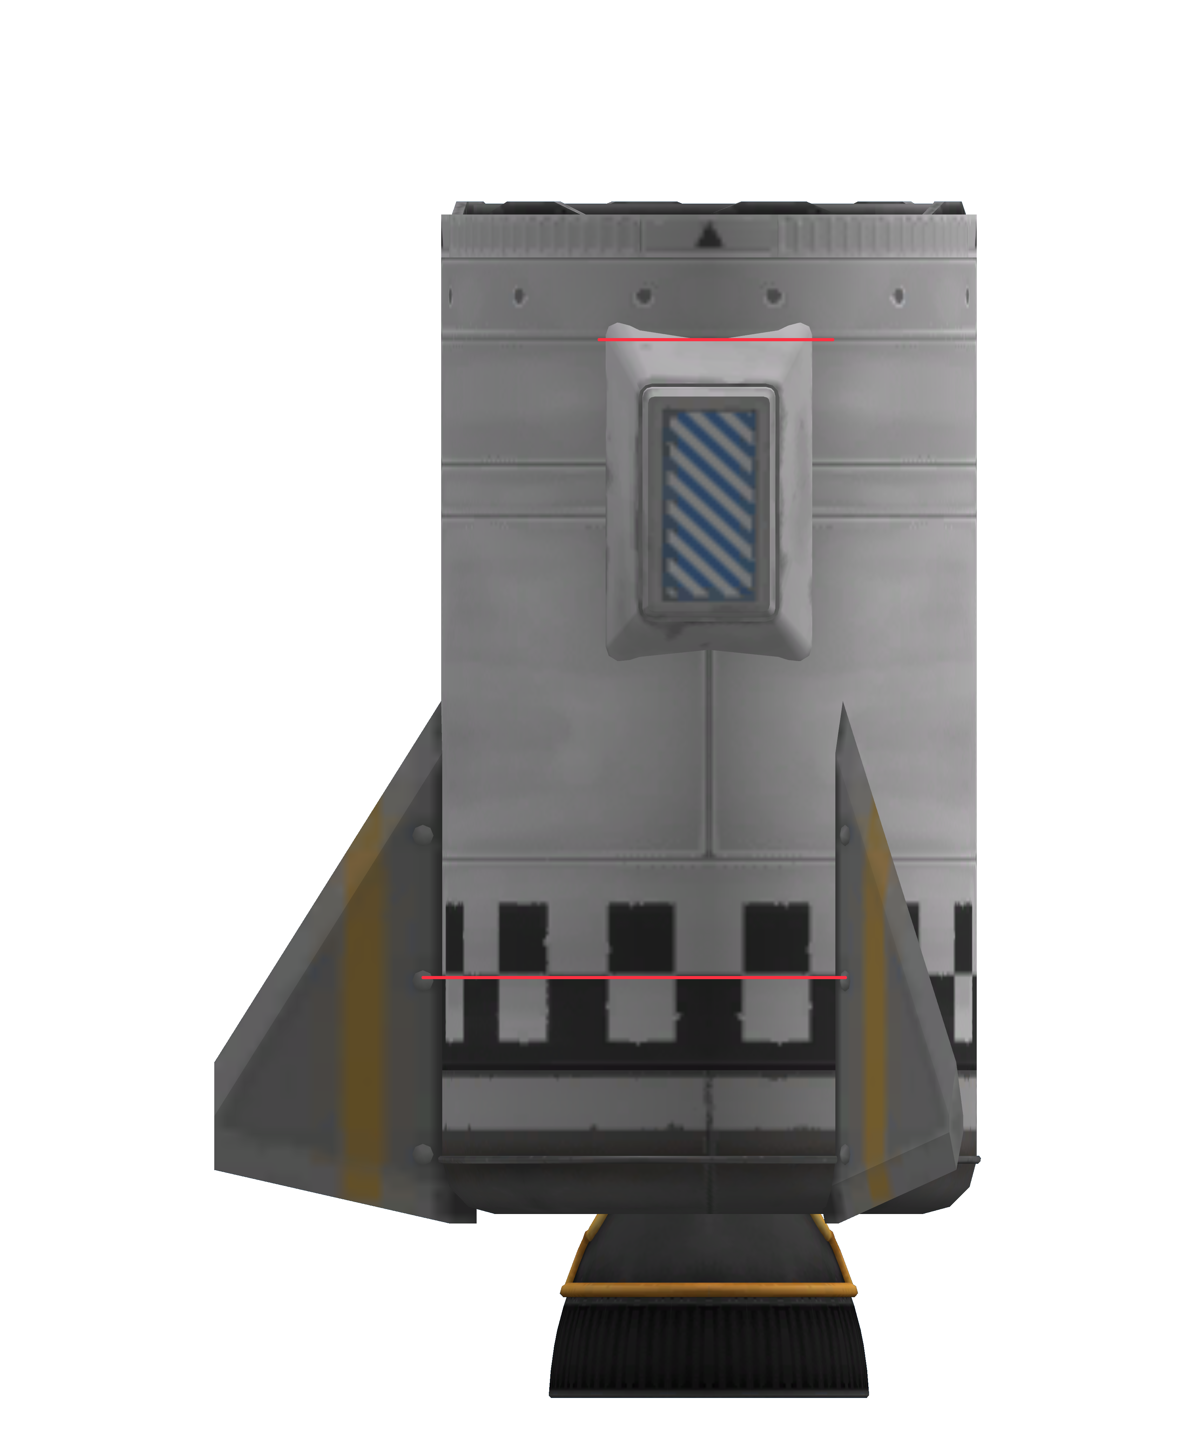Figure 1: SM-1 final assembly with marks showing positioning of parachutes and fins

Stage configuration
Part | Variable | Value | Default | Notes
Engine | Thrust limiter | 100 | Yes
 | Throttle | Main throttle | Yes
LFOX tank | Flow Priority | 0 | Yes
Decoupler | Force percent | 100 | Yes
 | Enable crossfeed | False | Yes
 | Enable staging | True | Yes
Parachutes | Deploy mode | When safe | Yes
 | Min pressure | 0.45 | No
 | Altitude | 500 | No
 | Spread angle | 10 | No

Staging
Stage | Parts | Notes
0 | Parachutes, decoupler
1 | Engine

Parameters
Parameter | Value
Mass (dry, kg) | 1020
Mass (wet, kg) | 3020
Cost (wet) | 1965
Cost (dry) | 1781
Part count | 8

Post flight maintenance
- SM-1 Decoupler
  - Enable staging
- Tanks
  - Fill

Pre flight checks
- Verify staging
- Verify parachute settings

